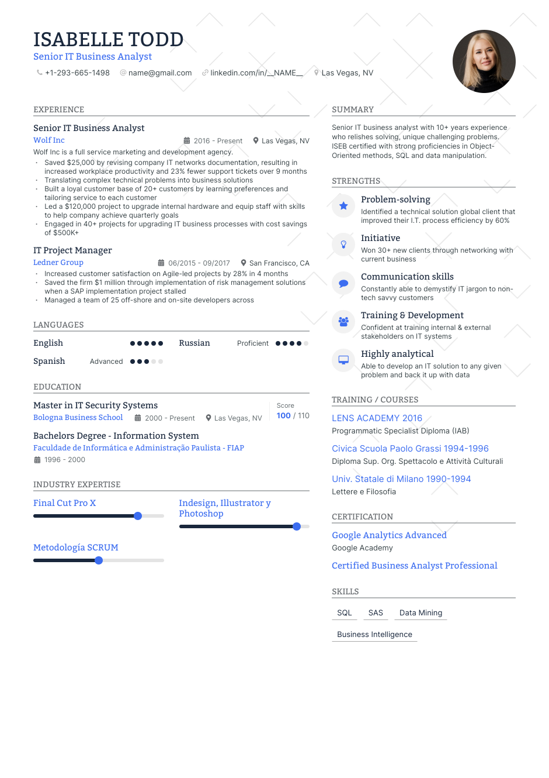
ISABELLE TODD
Senior IT Business Analyst
+1-293-665-1498
@name@gmail.com linkedin.com/in/_NAME_ Las Vegas, NV
EXPERIENCE
Senior IT Business Analyst
Wolf Inc
2016 Present
• Las Vegas, NV
Wolf Inc is a full service marketing and development agency. Saved $25,000 by revising company IT networks documentation, resulting in increased workplace productivity and 23% fewer support tickets over 9 months Translating complex technical problems into business solutions
Built a loyal customer base of 20+ customers by learning preferences and tailoring service to each customer
Led a $120,000 project to upgrade internal hardware and equip staff with skills to help company achieve quarterly goals
⚫ Engaged in 40+ projects for upgrading IT business processes with cost savings of $500K+
IT Project Manager
Ledner Group
06/2015-09/2017 San Francisco, CA
Increased customer satisfaction on Agile-led projects by 28% in 4 months Saved the firm $1 million through implementation of risk management solutions when a SAP implementation project stalled
Managed a team of 25 off-shore and on-site developers across
SUMMARY
Senior IT business analyst with 10+ years experience who relishes solving, unique challenging problems. ISEB certified with strong proficiencies in Object- Oriented methods, SQL and data manipulation.
STRENGTHS
Problem-solving
Identified a technical solution global client that improved their I.T. process efficiency by 60% Initiative
Won 30+ new clients through networking with current business
Communication skills
Constantly able to demystify IT jargon to non- tech savvy customers
Training & Development
Confident at training internal & external stakeholders on IT systems
Highly analytical
Able to develop an IT solution to any given problem and back it up with data
LANGUAGES
English
Russian
Proficient
Spanish
Advanced
EDUCATION
Master in IT Security Systems
Bologna Business School
2000 - Present Las Vegas, NV
Score 100 / 110
LENS ACADEMY 2016
TRAINING/COURSES
Bachelors Degree - Information System
Faculdade de Informática e Administração Paulista - FIAP
1996-2000
INDUSTRY EXPERTISE
Final Cut Pro X
Metodología SCRUM
Indesign, Illustrator y Photoshop
Programmatic Specialist Diploma (IAB)
Civica Scuola Paolo Grassi 1994-1996
Diploma Sup. Org. Spettacolo e Attività Culturali
Univ. Statale di Milano 1990-1994 Lettere e Filosofia
CERTIFICATION
Google Analytics Advanced
Google Academy
Certified Business Analyst Professional
SKILLS
SQL SAS Data Mining
Business Intelligence

